A.KPI’s

1.Total Revenue:
Select SUM(total_price) As Total_Revenue from pizza_sales;
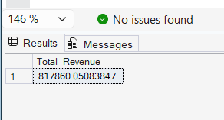

2.Average Order Value:
select sum(total_price)/count(distinct order_id) as avg_order_value from pizza_sales
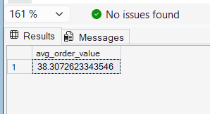

3.Total Pizza Sold:
select sum(quantity) as Total_Pizza_Sold from pizza_sales;
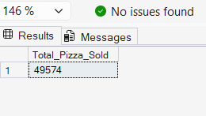

4.Total Orders:
Select count (distinct order_id) as Total_Orders from pizza_sales;
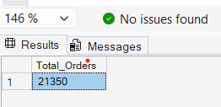

5.Average Pizza per order:
Select SUM(quantity) As DECIMAL(10,2)/COUNT(DISTINCT order_id) as DECIMAL(10,2) as Avg_pizzas_per_order from pizaa_Sales;
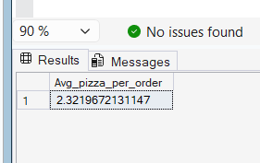

B.Daily Trend for Total Orders:
select DATENAME(DW,order_date) as order_day, count(distinct order_id) as Total_orders
from pizza_sales
group by DATENAME(DW,order_date)

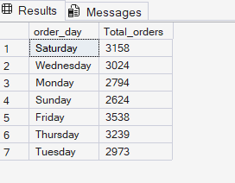

C.Monthly Trend for Orders:
select DATENAME(MONTH,order_date) as Month_name,count(distinct order_id) as Total_orders
from pizza_sales
GROUP BY DATENAME(MONTH,order_date)
ORDER BY Total_orders DESC
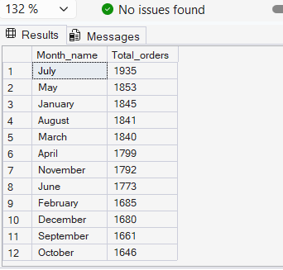

D.% Of Sales by Pizza Category:
select pizza_category,sum(total_price) as Total_sales,sum(total_price)*100 / (select sum(total_price) from pizza_sales) as PCT
from pizza_sales
GROUP BY pizza_category
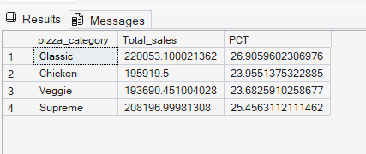

E.% Of Sales by Pizza Size:
select pizza_size,sum(total_price) as Total_sales,sum(total_price)*100 / (select sum(total_price) from pizza_sales) as PCT
from pizza_sales
GROUP BY pizza_size
ORDER BY pizza_size

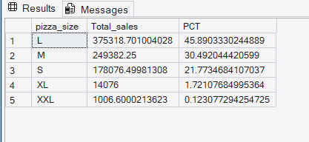

F.Total Pizzas Sold by Pizza Category:
select pizza_category,sum(quantity) as Total_Quantity_Sold
from pizza_sales
group by pizza_category
order by Total_Quantity_Sold DESC
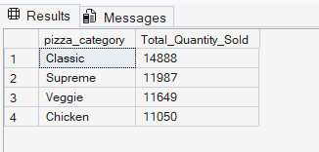

G.Top 5 Pizzas by Revenue:
select Top 5 pizza_name,sum(total_price) as Total_Revenue
from pizza_sales
group by pizza_name
order by Total_Revenue DESC
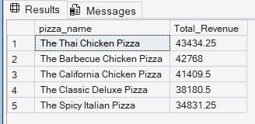

H.Bottom 5 Pizzas by Revenue:
select Top 5 pizza_name,sum(total_price) as Total_Revenue
from pizza_sales
group by pizza_name
order by Total_Revenue ASC

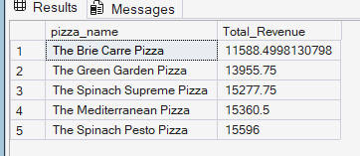

I.Top 5 Pizzas by Quantity:
select Top 5 pizza_name,sum(quantity) as Total_pizza_sold
from pizza_sales
group by pizza_name
order by Total_pizza_sold DESC

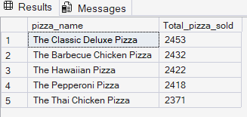

J.Bottom 5 Pizzas by Quantity:
select Top 5 pizza_name,sum(quantity) as Total_pizza_sold
from pizza_sales
group by pizza_name
order by Total_pizza_sold ASC

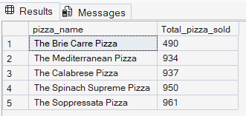

K.Top 5 Pizzas by Total Orders:
select Top 5 pizza_name,count(distinct order_id) as Total_orders
from pizza_sales
group by pizza_name
order by Total_orders DESC
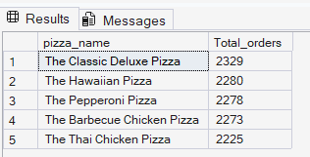

L.Bottom 5 Pizzas by Total Orders:

select Top 5 pizza_name,count(distinct order_id) as Total_orders
from pizza_sales
group by pizza_name
order by Total_orders ASC

